***PAAREES PERFUMES***

***VERSACE***

***FOR MEN***

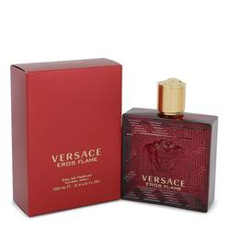

# 

***VERSACE EROS FLAME***

## *Description:*

Versace Eros Flame by Versace Cologne. If you’re looking to add some sensuality to your style, Eros Flame will be your new signature scent. Inspired by Eros, also known as Cupid, this fragrance was designed for the man of carnal desires. Accords of spices, woods and citrus create this harmonious blend sure to excite your lover. Top notes of rosemary, mandarin, black pepper and lemon begin the scent profile with a bang. These explosive notes are followed by a softer heart accord of geranium and rose. The scent is rounded out by a sensual base of oakmoss, Tonka bean, vanilla, cedar and sandalwood. Launched in 2018, this cologne is available as a 3.4-ounce eau de parfum and is packaged in a fire red flacon emblazoned with the head of Eros, the God of Love.